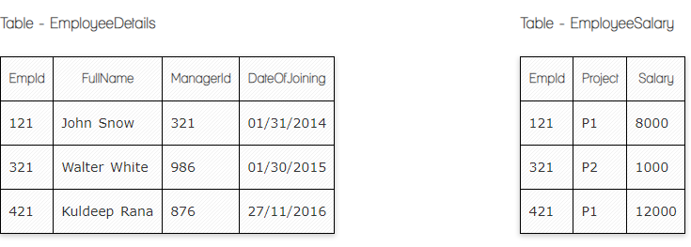

**Ques.1. Write a SQL query to fetch the count of employees working in project 'P1'.**

Select count(EmpID), Project EmployeeSalary

Group by Project

having Project=”P1”

Oreder by count(EmpID);



**Ques.2. Write a SQL query to fetch employee names having salary greater than or equal to 5000 and less than or equal 10000.**

**EmpId in EmployeeDetails table is a primary key and in a EmployeeSalary is a foreign key.**

Select EmployeeDetails.Fulname, EmployeeSalary.Salary

From EmployeeDetails

Inner join EmployeeSalary on EmployeeDetails.EmpID= EmployeeSalary. EmpID

Where salary between 5000 and 1000



**Ques.3. Write a SQL query to fetch count of employees sorted by project's count in descending order.**

Select count(EmpID), project EmployeeSalary

Group by Project

Oreder by count(EmpID) desc;



**Ques.4. Write a query to fetch employee names and salary records. Return employee details even if the salary record is not present for the employee.**

Select EmployeeDetails.Fulname, EmployeeSalary.Salary

From EmployeeDetails

Left join EmployeeSalary on EmployeeDetails.EmpID = EmployeeSalary. EmpID

**Ques.5. Write a SQL query to create an empty table with ‘Test’ name.**

Create table Test ("")

**Ques.6. Write a SQL query to delete an empty table with ‘Test’ name.**

Drop table Test



**Ques.7. Write a SQL query to fetch all the Employees details from EmployeeDetails table who joined in Year 2016.**

Select * from mployeeDetails

Where Dateof joining between~~=~~”01/01/2016” and 31/12/2016

**Ques.8. Write a SQL query to insert new record to the EmployeeDetails table with any data.**

Insert into EmployeeDetails ( FullName, managerID, Dateofjoining)

Values (“Jhon Smith”, 123, “02/28/2022” )

**Ques.9. Write a SQL query to update EmployeeSalery table with setting Salary to 2000 for Project P2.**

Update EmployeeSalery

set Salary=2000 where project=”p2”



**Ques.10. Write a SQL query to right join both tables and draw the results.**

Select EmployeeDetails.managerID, EmployeeSalary.Salary

From EmployeeDetails

right join EmployeeSalary on EmployeeDetails.EmpID= EmployeeSalary. EmpID

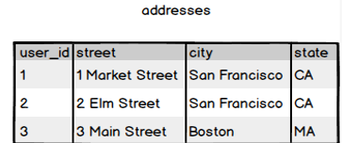

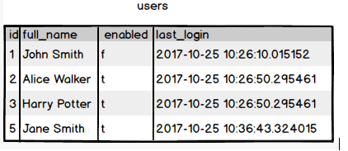

**Ques.11. Write a SQL query to fetch all users full_name from San Francisco.**

Select users.full_name, adresses.city From users

inner join adresses on users.ID = Addresses.User_ID

where city=”San Francisco”

**Ques.12. Write a SQL query to fetch all users full_name, last_login who are enabled**

Select full_name, last_login from users where enabled=’t’

**Ques.13. Write a SQL query to fetch all users full_name who are not from Main street**

Select users.full_name, adresses.street From users

inner join adresses on users.ID = Addresses.User_ID

where street != “Main street”

**Ques.14. Write a SQL query to fetch all users full_name who are from Main street or San Francisco**

Select users.full_name, adresses.street From users

inner join adresses on users.ID = Addresses.User_ID

WHERE street = '3 Main Street' OR city = 'San Francisco'

**Ques.15. Write a SQL query to fetch user full_name who is equal to user_id from Boston (find user_id value in sub_query)**

Select full_name from usesrs where user_id = (Select user_Id from addresses where city=’Boston’)